**74182 Carry Look-Ahead Circuit**

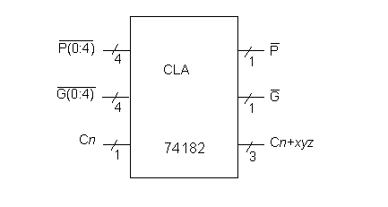

**Statistics:** 9 inputs; 4 output; 19 gates; [gate-level schematic](http://web.eecs.umich.edu/%7Ejhayes/iscas.restore/74182gates.html)

**Function:** The carry look-ahead (CLA) realization of the carry function is used by each of the 74X-series circuits modeled here. Given carry-in (C_n), generate (G) and propagate (P) signals, the circuit produces three carry out signals, plus two P and G signals used to cascade into another CLA block. This circuit is small enough to be modeled as a single primitive.

**Models:**

* [74182 ISCAS-85 netlist](http://web.eecs.umich.edu/%7Ejhayes/iscas.restore/74182.isc)
* [74182 Verilog structural model](http://web.eecs.umich.edu/%7Ejhayes/iscas.restore/74182.v)
* [74182 behavioral model](http://web.eecs.umich.edu/%7Ejhayes/iscas.restore/74182b.v)
* [74182 complete gate-level tests (CN, PB[3:0], GB[3:0])](http://web.eecs.umich.edu/%7Ejhayes/iscas.restore/74182.tests)

**74182 Gate-Level Schematic**

